BrownRice/Sorghum/Teff & Millet Flour, xanthan & guar gum 11 Bread

Preparatory & Background Info
- Use a three quart batter bowl (light, works well for dry ingredients)
- Use a 8 cup beaker for the wet so there’s space for beating the eggs.
- Original source
Ingredients:

Wet
- 15.6 oz lactose free skim milk
- Two jumbo egg whitess, room temp, beaten
- 1tsp/.2 oz apple cider vinegar
- 2 oz olive oil
- 5.5 oz yogurt
- 2 oz maple syrup
Dry
- 4.5 oz brown rice flour
- 4.5 oz sorghum flour
- 4.5 oz teff flour
- 4.5 oz millet flour
- .2 oz xanthan, .1 os guar gums
- .25 oz salt
- 2 tsp active dry yeast, added last thing into pan

In a large bowl, mix the flour ingredients, salt and xanthan/guar gums well with a whisk

Combine the liquid ingredients (milk, beaten eggs, apple cider vinegar, vegetable oil and maple syrup) and whisk to a froth to make sure the eggs are well beaten. Microwave for one minute.

Spray the sides of the bread machine’s pan to add release after baking; this Rx tends to stick to the pan

Pour liquid into the bread machine pan. Add the flour mixture to the baking pan; it will float atop the liquid.. Make a small indentation in the flour with a spoon, and place the yeast there. Make sure the yeast does not touch any liquid.

Select Custom Home-Made #1 (Rest:0, Knead:20, R1:0, R2:0, Rise3: 45, Bake: 90 and press Start. After it’s been mixing for a while, open the lid and use a rubber spatula to push down flour that may be stuck to the sides of the baking pan

When bake is done,, check the temp, which should read 205º or more, if it isn’t, add extra time to your bread maker or put the bread maker loaf pan into your oven on 350° F for another 5-10 minutes (keep taking its temperature).

Run grey plastic spatula around the pan edge to help bread release

Dough looked like this at end of mixing…and the baked loaf and crumb
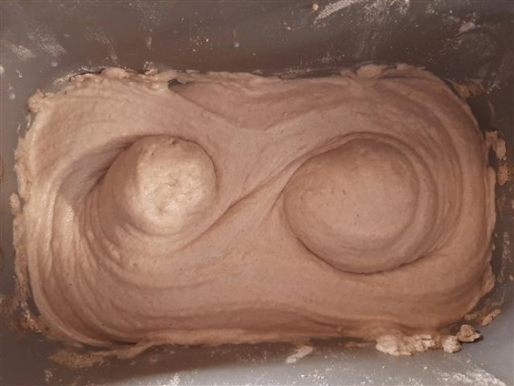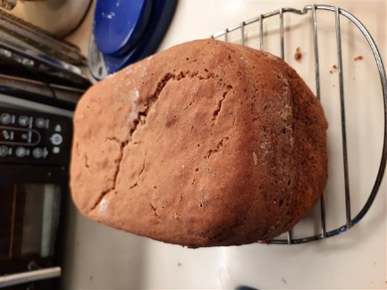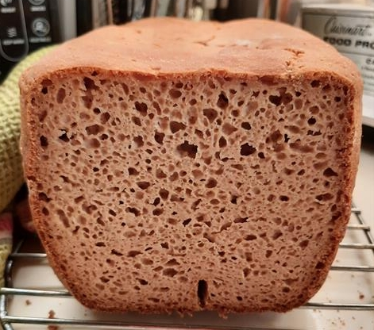
Next time: Try .2 oz guar. Ask forum the ideal GF hydration for best rise.

Cost

Maple Syrup, $12/qt, 2 oz=75¢
Olive Oil: $12/48oz, 30¢/oz, 1 oz=25¢
Milk: $3.38/64oz, 5.3¢/oz,19.2oz=$1.02
Brown Rice Flour: $8.17/5lb, 10.2¢/oz, $.80
Potato Starch: $2.65/lb, 17¢/oz, 7.8oz=$1.29
Xanthan Gum $5.59/6oz, 93¢/oz, .28oz=26¢
Oat Flour: $1.50/lb, 9¢/oz, 5.3 oz=50¢
Eggs: $4.80/doz, 40¢@, 40¢
Yeast: $3/16oz, 19¢/oz,.3oz=6¢

Total Cost: = .75 + .25 + .1.02 + .80 + 1.29 + .26 + .50 + .40 + .06 = $5.33

Notes:
- Xanthan gum appears to give Carol gas. Cutting back on it makes it fall worse. Am now using .2 oz of it, which seems to be OK
- Gluten Free breads do not need and must not be kneaded, just mixed because there is no gluten to develop!
- Observe the hydration after the machine has been beating for 4 minutes and thereafter. The Dough should be between runny and doughy; fear not. There may be two peaks forming over the beaters. Adjust hydration, if necessary by adding milk, an once or two if too dry, rice flour if too wet…weigh what you add and record it.

https://gfjules.com/baking-gluten-free-bread-in-a-breadmaker/
How to Program Your Bread Machine for Gluten Free Bread: suggested 20-minute mix, a 40-minute rise and a 1-hour bake cycle. Do not allow the machine to do a “punch down” or second rise!

Always take your bread’s temperature before you take it out of the oven or the bread maker. It might look and smell done, but if it’s not over 205° F, it’s not done in the middle.

